HW #5 Quadrature
Name:JianWang FSUID:JW09R

0. Executive Summary
Write adaptive quadrature which uses simpson’s rule to calculate Gaussian probability function and obtain the result when the x is equal to 1.0 (at least six significant digits). Besides, use the function defined above to calculate the result of the call option via the B-S formula(in four digit numbers). Finally, I use bisection method to find out the implied volatility (in four significant digits). The result are listed as follows:

- Statement of Problem
To find the value of the call option price, we should use the adaptive quadrature method to calculate the Gaussian probability which can not derive the value of the integral directly. Besides, show the algorithm is working correctly. In the end, to find the volatility of the BS model given the assumptions.

- Description of The Mathematics
The two order of quadrature polynomial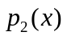is:
Where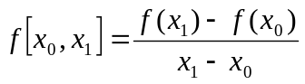, 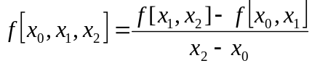
From this we can get the approximation of the integral as follows:
where 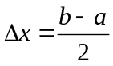

With the help of Taylor’s expansion , we can get the Error E, the process is as follows:
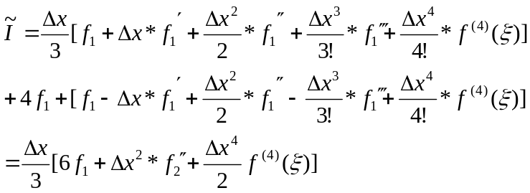
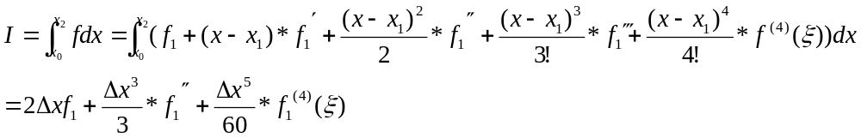 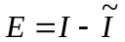 such that:
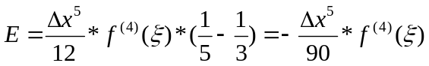
We also know that
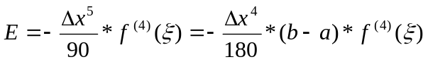
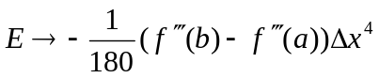 when 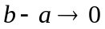
So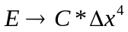, when 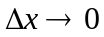, where 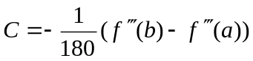 is a constant
So if we half the interval each time, and let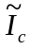, 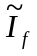 keep the values of two rounds calculation. 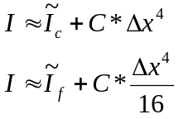
In the adaptive method, we use 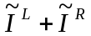 instead of. Then we got the formula as below:
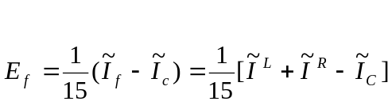
So we can make sure the total error less than given Tollerance by only checking 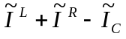

- Description of the Algorithm
Simpson’s Rule algorithm:
Define f to be integrated function, [a,b] to be the closed interval.
Input f,a,b
Return (f(a)+f(a+(b-a)/2)*4+f(b))*(b-a)/6
END

Adaptive algorithm
Define f to be integrated function, [a,b] to be the closed interval, Tol is the given absolute error.
Input f, a, b, Tol
Ic = Simpson (f, a, b)
If = Simpson (f, a, (a+b)/2) + Simpson (f, (a+b)/2, b)
E = (If-Ic)/15
IF abs(E) > Tol
IL=adaptive ( f, a, (a+b)/2, Tol/2 )
IR=adaptive ( f, (a+b)/2, b, Tol/2)
Return IL+IR
Otherwise
Return If+E
End if
END

- Results

  - The integral of Gaussian probability function from minus infinity to 1 is 0.841345 with six significant numbers
  - The calculated Call option price is 98.5678 with four significant numbers
  - The calculated implied volatility is 7.6088% with four significant numbers.
The detail of calculation process listed below:

A. Gaussian probability
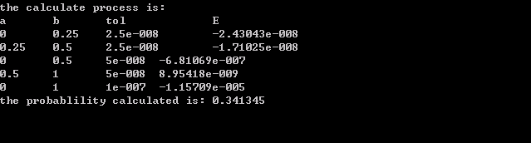
Since the Gaussian probability function integrated from minus infinity to 0 is 0.5. so the probability from minus infinity to 1 is 0.834134, with six significant digits.
Since the absolute error is bounded by the parameter Tol which is chosen as 10E-7, and P>0.5, so the relative error 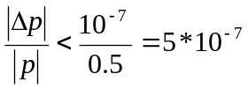 and the answer has six significant digits.

B. Call option price and implied volatility
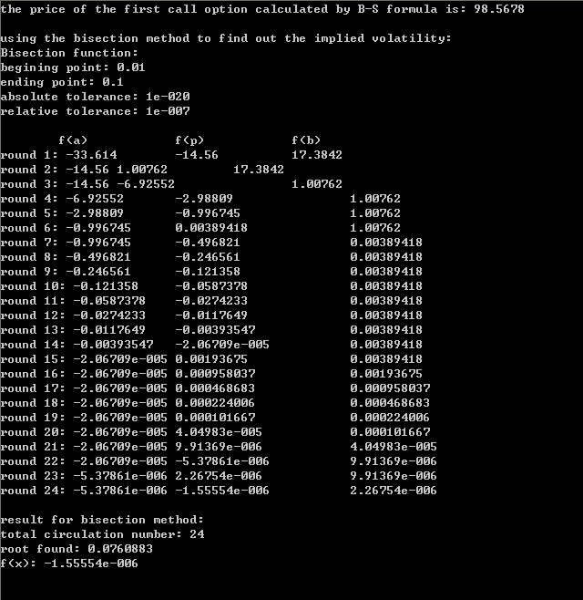
The calculated call option price is 98.5678 with 4 significant numbers.
To analyze the significant number we should assume every parameter precise and only the calculated Gaussian probability not precise.
S= 3441.0
K=3425.0
r=6.75%
T=54/365
T=0
C100
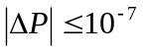 which is the Tol in program.
So:
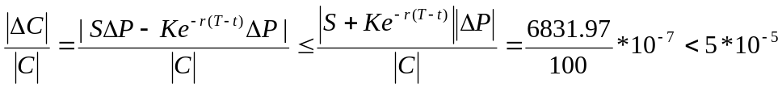

In addition, to calculate the implied volatility, I use bisection method which was written before and the volatility rate is 7.609% with 4 significant numbers.

- Conclusions
In order to make sure the calculation is correct, we need to testify the routine of adaptive Simpson’s method with some functions whose integrals we already know.
a. check the functions f(x)=x, f(x)=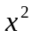, f(x)=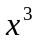
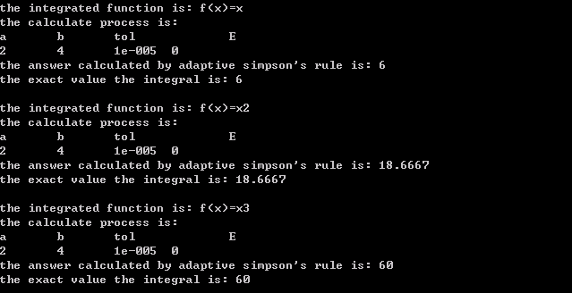
The outcome satisfies the theory that the error should be 0 when the order is less than 3.

b. check the functions f(x)=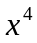
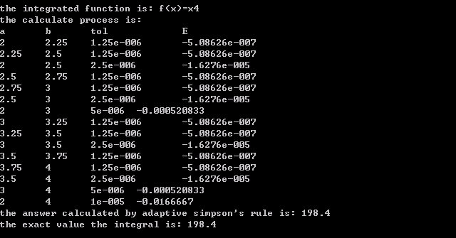

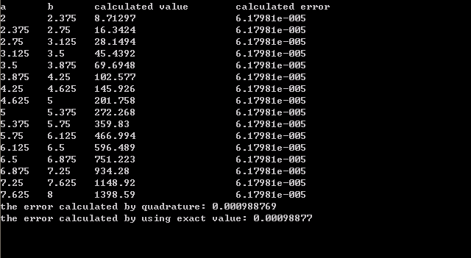
The outcomes listed above tell us the process of calculation: we half interval into left-half and right-half until the calculated error in each interval is less then the anticipated error. This process satisfies the thought of adaptive method.
In addition, since the error polynomial is of 4th order, so if we use Simpson’s rule method to calculate every same small interval, we shall get the same calculated error. The second graph listed above showed out process has this property.

c. check other functions:
At last I checked some other functions and the outcomes show that the calculated integral and the exact integral are the same. The graphs are listed below.
Function list: f(x)=1/x, f(x)=1/x2, f(x)=x5, f(x)=sin(x).
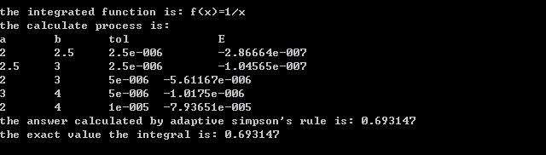
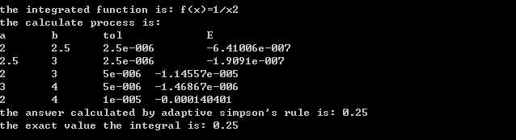
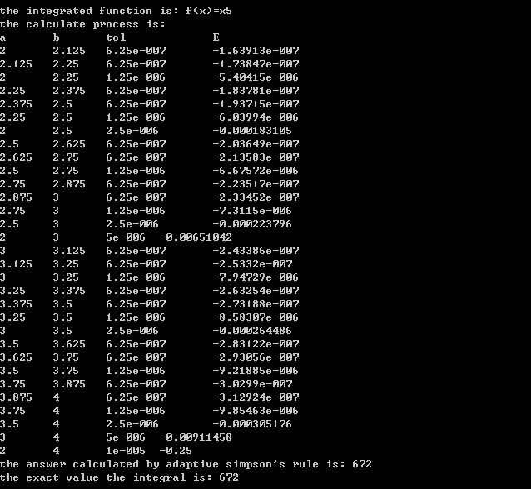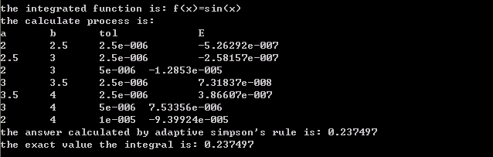

- Code Listing

<Quadrature.h>
#ifndef QUADRATURE_H
#define QUADRATURE_H
#define FMFLOAT double

class Quadrature
{
public:
FMFLOAT Simpson(FMFLOAT (*f)(FMFLOAT i), FMFLOAT a, FMFLOAT b);
FMFLOAT Adaptive(FMFLOAT (*f)(FMFLOAT i), FMFLOAT a, FMFLOAT b, FMFLOAT Tol);
//FMFLOAT Gaussian(FMFLOAT i);
};
#endif;

<rootfinding.h>
#define ROOTFINDING_H
#include "FMFLOAT.h"
#define FMFLOAT double

class rootfinding
{
public:

FMFLOAT Bisect(FMFLOAT (*f1)(FMFLOAT x), FMFLOAT a, FMFLOAT b, FMFLOAT absTol, FMFLOAT relTol);
FMFLOAT Newton(FMFLOAT (*f1)(FMFLOAT x), FMFLOAT (*f2)(FMFLOAT y), FMFLOAT startvalue, FMFLOAT, FMFLOAT);
FMFLOAT Solve(FMFLOAT (*f1)(FMFLOAT), FMFLOAT (*f2)(FMFLOAT), FMFLOAT a, FMFLOAT b, FMFLOAT absTol, FMFLOAT relTol);
private:
int sign(FMFLOAT (*f)(FMFLOAT), FMFLOAT i);
};

<quadrature.cpp>
#include "Quadrature.h"
#include <math.h>
#include <iostream>
using namespace std;

FMFLOAT Quadrature::Simpson(FMFLOAT (*f)(FMFLOAT i), FMFLOAT a, FMFLOAT b)
{
return (f(a)+f(a+(b-a)/2)*4+f(b))*(b-a)/6;
}

FMFLOAT Quadrature::Adaptive(FMFLOAT (*f)(FMFLOAT i), FMFLOAT a, FMFLOAT b, FMFLOAT Tol)
{
FMFLOAT Ic,If,Il,Ir,E;
Ic=Simpson(*f,a,b);
If=Simpson(*f,a,a+(b-a)/2)+Simpson(*f,a+(b-a)/2,b);
E=(If-Ic)/15;
if (abs(E)>Tol)
{
Il=Adaptive(*f,a,a+(b-a)/2,Tol/2);
Ir=Adaptive(*f,a+(b-a)/2,b,Tol/2);
// cout<<a<<'\t'<<b<<'\t'<<Tol<<'\t'<<E<<endl;//'\t'<<Ic<<'\t'<<Il+Ir<<endl;
return Il+Ir;
}
else
{
// cout<<a<<'\t'<<b<<'\t'<<Tol<<'\t'<<E<<endl;//'\t'<<"If+E "<<'\t'<<Ic<<'\t'<<If+E<<endl;
return If+E;
}
}

<rootfinding.h>
#include "Quadrature.h"
#include <math.h>
#include <iostream>
using namespace std;

FMFLOAT Quadrature::Simpson(FMFLOAT (*f)(FMFLOAT i), FMFLOAT a, FMFLOAT b)
{
return (f(a)+f(a+(b-a)/2)*4+f(b))*(b-a)/6;
}

FMFLOAT Quadrature::Adaptive(FMFLOAT (*f)(FMFLOAT i), FMFLOAT a, FMFLOAT b, FMFLOAT Tol)
{
FMFLOAT Ic,If,Il,Ir,E;
Ic=Simpson(*f,a,b);
If=Simpson(*f,a,a+(b-a)/2)+Simpson(*f,a+(b-a)/2,b);
E=(If-Ic)/15;
if (abs(E)>Tol)
{
Il=Adaptive(*f,a,a+(b-a)/2,Tol/2);
Ir=Adaptive(*f,a+(b-a)/2,b,Tol/2);
// cout<<a<<'\t'<<b<<'\t'<<Tol<<'\t'<<E<<endl;//'\t'<<Ic<<'\t'<<Il+Ir<<endl;
return Il+Ir;
}
else
{
// cout<<a<<'\t'<<b<<'\t'<<Tol<<'\t'<<E<<endl;//'\t'<<"If+E "<<'\t'<<Ic<<'\t'<<If+E<<endl;
return If+E;
}
}

<main.cpp>
#include "rootfinding.h"
#include "Quadrature.h"
#include <iostream>
#define _USE_MATH_DEFINES
#include <math.h>
#include <iomanip>
#include <string>
#include <fstream>
using namespace std;

FMFLOAT f1(FMFLOAT i)
{
return pow((M_E),(pow(i,2)*(-1)/2))/pow(2*(M_PI),0.5);
}

FMFLOAT test1(FMFLOAT i)
{
return pow(i,1);
}

FMFLOAT test2(FMFLOAT i)
{
return pow(i,2);
}
FMFLOAT test3(FMFLOAT i)
{
return pow(i,3);
}
FMFLOAT test4(FMFLOAT i)
{
return pow(i,4);
}
FMFLOAT test5(FMFLOAT i)
{
return pow(i,5);
}
FMFLOAT test6(FMFLOAT i)
{
return pow(i,-2);
}
FMFLOAT test7(FMFLOAT i)
{
return sin(i);
}
FMFLOAT test8(FMFLOAT i)
{
return pow(M_E,i);
}

FMFLOAT test9(FMFLOAT i)
{
return pow(i,-1);
}
FMFLOAT test1i(FMFLOAT a,FMFLOAT b)
{
return (pow(b,2)-pow(a,2))/2;
}

FMFLOAT test2i(FMFLOAT a,FMFLOAT b)
{
return (pow(b,3)-pow(a,3))/3;
}
FMFLOAT test3i(FMFLOAT a,FMFLOAT b)
{
return (pow(b,4)-pow(a,4))/4;
}
FMFLOAT test4i(FMFLOAT a,FMFLOAT b)
{
return (pow(b,5)-pow(a,5))/5;
}
FMFLOAT test5i(FMFLOAT a,FMFLOAT b)
{
return (pow(b,6)-pow(a,6))/6;
}
FMFLOAT test6i(FMFLOAT a,FMFLOAT b)
{
return (pow(b,-1)-pow(a,-1))*(-1);
}
FMFLOAT test7i(FMFLOAT a,FMFLOAT b)
{
return (-1)*(cos(b)-cos(a));
}
FMFLOAT test8i(FMFLOAT a,FMFLOAT b)
{
return pow(M_E,b)-pow(M_E,a);
}

FMFLOAT test9i(FMFLOAT a,FMFLOAT b)
{
return log(b)-log(a);
}

FMFLOAT C1(FMFLOAT S, FMFLOAT K, FMFLOAT r, FMFLOAT d, FMFLOAT T, FMFLOAT t)
{
FMFLOAT k1=(log(S/K)+(r+d*d/2)*(T-t))/(d*pow(T-t,0.5));
FMFLOAT k2=(log(S/K)+(r-pow(d,2)/2)*(T-t))/(d*pow(T-t,0.5));
Quadrature a;
FMFLOAT pd1, pd2;
if (k1>=0) pd1=0.5+a.Adaptive(*f1,0,k1,pow(10.0,-7));
else pd1=0.5-a.Adaptive(*f1,0,-k1,pow(10.0,-7));
if (k2>=0) pd2=0.5+a.Adaptive(*f1,0,k2,pow(10.0,-7));
else pd2=0.5-a.Adaptive(*f1,0,-k2,pow(10.0,-7));
return S*pd1-K*pow(M_E,(-1)*r*(T-t))*pd2;
}

FMFLOAT C2(FMFLOAT d)
{
return C1(3461.0,3475.0, 0.0675,d, 117.0/365.0,0)-94.0;
}

void main()
{
Quadrature a;
// cout<<setiosflags(ios::fixed)<<setprecision(15);
//calculate gaussian probability-----------------------------------------------------------------------------
cout<<"the calculate process is: "<<endl<<"a"<<'\t'<<"b"<<'\t'<<"tol"<<'\t'<<'\t'<<"E"<<endl;
double m=a.Adaptive(*f1,0,1,pow(10.0,-7));
cout<<"the probablility calculated is: "<<m<<endl;

//test pow(x,4) has constant error----------------------------------------------------------------------------
float sum=0;
cout<<"a"<<'\t'<<"b"<<'\t'<<"calculated value"<<'\t'<<"calculated error"<<endl;
for (int k=0;k<=15;k++)
{
cout<<2+k*0.375<<'\t'<<2+(k+1)*0.375<<'\t'<<a.Simpson(*test4,2+k*0.375,2+(k+1)*0.375)<<"\t\t\t"<<a.Simpson(*test4,2+k*0.375,2+(k+1)*0.375)-(pow(2.0f+(k+1)*0.375,5)-pow(2.0f+k*0.375,5))/5<<endl;
sum=sum+a.Simpson(*test4,2+k*0.375,2+(k+1)*0.375)-(pow(2.0f+(k+1)*0.375,5)-pow(2.0f+k*0.375,5))/5;
}
cout<<"the error calculated by quadrature: "<<sum<<endl;
cout<<"the error calculated by using exact value: "<<6.0f*pow(0.1875,4)*4*3*2/180<<endl;

//calculate call option price-------------------------------------------------------------------------------

FMFLOAT d1,d2;
cout<<"the price of the first call option calculated by B-S formula is: ";
cout<<C1(3441.0,3425.0,0.0675,0.135,54.0/365.0,0)<<endl<<endl;
//cout<<C2(0.01)<<endl;
cout<<"using the bisection method to find out the implied volatility:"<<endl;
rootfinding b;
b.Bisect(*C2,0.01,0.1,pow(10.0,-20),pow(10.0,-7));
cout<<endl<<endl;

//test functions------------------------------------------------------------------------

double (*fp[9])(double i)={&test1,&test2,&test3,&test4,&test5,&test6,&test7,&test8,&test9};
string fps[9] ={"f(x)=x","f(x)=x2","f(x)=x3","f(x)=x4","f(x)=x5","f(x)=1/x2","f(x)=sin(x)","f(x)=ex","f(x)=1/x"};
double (*fpi[9])(double a,double b)={&test1i,&test2i,&test3i,&test4i,&test5i,&test6i,&test7i,&test8i,&test9i};
for (int k=0;k<=3;k++)
{
cout<<"the integrated function is: "<<fps[k]<<endl;
cout<<"the calculate process is: "<<endl<<"a"<<'\t'<<"b"<<'\t'<<"tol"<<'\t'<<'\t'<<"E"<<endl;
cout<<"the answer calculated by adaptive simpson's rule is: "<<a.Adaptive(fp[k],2,10,pow(10.0,-5))<<endl;

cout<<"the exact value the integral is: "<<fpi[k](2,10)<<endl;
cout<<endl;
}
}

